Expanding on the Principles of Psychological First Aid.
When key workers contact families, we felt it might be useful to bear in mind the principles of ‘Psychological First Aid’. This approach is utilised by the EP team during our meetings with young people following a critical incident (that is, when they have experienced an out of the ordinary, potentially traumatic event).
Please see details below:
  - Make a connection – at present this is likely to be over the telephone, but please consider video messaging if possible, as face-to-face connection is preferable, enabling us to read and respond to facial expression.
  - Help people be safe – we could use this opportunity to reinforce government advice on keeping safe via physical distancing and also to thank families for doing so. Asking about any concerns about wider safety might also be helpful.
  - Be kind, calm and compassionate – it goes without saying emotions are running high at such an uncertain, difficult time. Some kind, calm, compassionate words go a long way.
  - Meet people’s basic needs – this links nicely into Lisa’s suggested questions about whether the family are getting their basic needs met. We could also consider Maslow’s Hierarchy of Needs here (see below). If we consider our most basic need is for physical survival, this will be the first thing that motivates our behaviour. These are the biological requirements for human survival, e.g. air, food, drink, shelter, clothing, warmth, sex, sleep. If these needs are not satisfied the human body cannot function optimally. The impact of the current COVID-19 situation on each of these physiological needs is clear (limited access to/rationing of food, over-crowding in houses with everyone home all day, lack of sleep due to anxiety etc.) so it is therefore imperative that we check if these basic needs are being met, if at all possible.
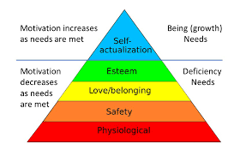
  - Listen – whilst it is important to impart much needed information, and indeed clarify misinformation which may be circulating, it is also vital to provide a ‘listening ear’. Use of Motivational Interviewing techniques (see OARS below) and Active Listening will be really useful here.
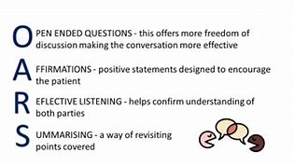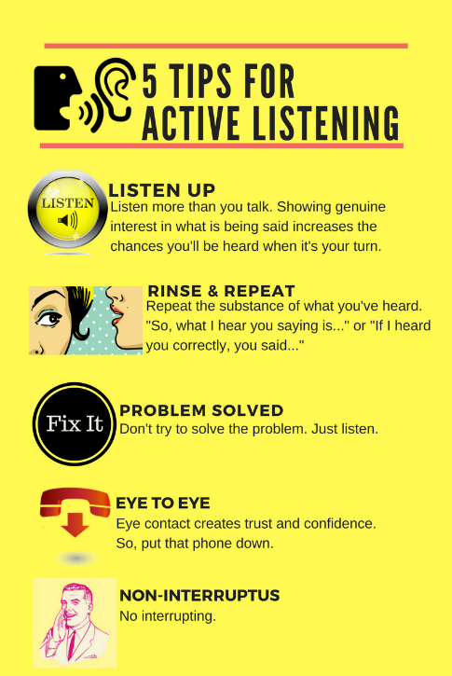

  - Give realistic reassurance – we will need to assure families are aware of supports available to them, as well as reinforcing positive, factually correct messages from government (e.g. the start of China’s recovery process).
  - Encourage good coping – please explore what the family have done in the past to cope with challenging situations and therefore what resources, activities and techniques they might employ at this difficult time. Coping efforts are believed to be effective as long as children can sustain their basic routine. Creating a sense of adult support and normalcy (to the extent possible) is therefore critical in helping children deal with psychological stress. Many of you will be aware of the SPICES model of coping, shared in ACES training:
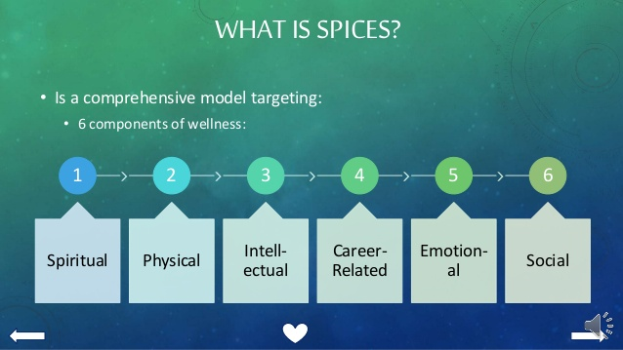
  - Help people connect – it will be helpful to establish how families are connecting with friends and family, whether via FaceTime, social media, Party Apps, YouTube religious sermons/meetings, online exercise or choirs etc. Reinforcing the ‘physical distancing, but social connecting’ message, rather than ‘social distancing’ will be helpful.
  - Give accurate and timely information – given the incredible amount of information (and misinformation) being shared online, it is essential that guidance from the LA is clear and concise. Please also share the BPS information about talking to children about Coronavirus with families https://edpsy.org.uk/blog/2020/coronavirus-covid-19-information-for-children-families-and-professionals/
  - Make appropriate referrals – Many services are continuing to provide support online or via telephone, for example The Exchange and Eye to Eye counselling. The WHO has recently published considerations to support mental health and wellbeing during the Coronavirus outbreak. This guidance has specific recommendations for health care workers, caretakers of children, caretakers of older adults and people in isolation.
  - Take care of yourself – professional supervision is vital. Please ensure you ‘check in’ and debrief with colleagues, friends and family at the end of each day and consider the coping strategies mentioned above.

