A1 – Multi Agency Suspected Adult at Risk Report

Section 1

This section is to be completed where there is reasonable cause to suspect that an adult is at risk of, or has experienced, abuse or neglect or that a professional may be unsuitable to work with adults at risk, and there is a statutory duty to share the individual’s personal information in line with Part 7, Social Services and Well-being Act (2014) Wales.

Adult at Risk – Definition (please refer to A1 Guidance document)
An 'adult at risk' is a person aged 18 years or older who:
- is experiencing or is at risk of abuse or neglect,
- has needs for care and support (whether or not the Local Authority is meeting any of those needs), and
- as a result of those needs is unable to protect himself or herself against the abuse or neglect or the risk of it.

Please indicate below if this is a concern relating to:

Adult at Risk |  |  | Professional Concern |  |  |  | Both Adult at Risk and Professional Concern
If this is a professional concern, please provide details of the professional

Name |  | DOB |  | Address |  | Job Title/Responsibility |  | Details
Date alert / concern raised:
Date of incident(s)
Date received by MASH:

1. Details of Adult at Risk | Client / Patient ID No:
Last Name: |  | First Name:
Date of Birth: |  | Age:
Gender: | Male □ Female □ Transgender □ Other (please state) □  Prefer not to say □
Address:  (Normal residence) |  |  |  |  | Postcode
Current Location: |  |  |  |  | Postcode
Tel/Mobile: |  |  | Ethnicity (see guidance)
Email Address:

Interpreter required? | Yes □ No □  Details: |  | Preferred Language:
GP’s Name: |  |  | GP Tel Number:
Surgery Address:
Why is the person an ‘adult at risk’ at the time of the incident?
Does the adult at risk have an illness / disability or specific needs?
Is the adult at risk subject to any legislative powers? E.g. DoLS, Mental Health Act, Power of Attorney
Next of Kin: |  | Relationship:
Address:

Tel/Mobile:

Email Address:

Are there any other persons at risk living at the property?
Please give details of any other professionals involved in their care.
What action has been taken to safeguard the adult at risk?
2. About the alleged abuse
Type of alleged abuse: | Physical □ Sexual □ Financial □ Emotional / Psychological □ Neglect □
At what address did the abuse occur?
Please specify the specific location of the abuse E.g. hospital ward number, own home in bedroom
Is the abuse | Current □ Historical □
Please give a full description of alleged abuse / injuries:
(Please complete body map and forward to MASH if relevant)
Are there any further risks?
If yes, please explain.
3. Details of suspected perpetrator(s)
Last Name: |  |  |  | First Name:
Date of Birth: |  |  |  | Age:
Address: |  |  |  | Post Code:
Tel/Mobile:
Relationship to adult at risk
Is the perpetrator an adult at risk? If yes, explain why
If the perpetrator is an adult at risk, do they have capacity to understand their actions?
Occupation: |  |  |  | Employer
Is alleged perpetrator aware of the suspected adult at risk report? | Yes □ No □
Additional Perpetrator? | Yes □ No □  Details:
4. Details of Witness(es)
Last Name: |  |  |  | First name:
Date of Birth: |  |  |  | Age:
Address: |  |  |  | Post Code:
Tel/Mobile:
Occupation:
Relationship to adult at risk:
Is witness an adult at risk? If yes, explain why.
Additional witness □

5. Who has raised the concern? | This is the first person to whom the disclosure was first made – it may be a family member, witness, or a professional working with the adult at risk
Name:
Date of Birth: |  | Age:
Address: |  | Post Code:
Tel/Mobile:
Occupation: |  | Employer:
Relationship to adult at risk:
Does the reporter wish to remain anonymous?
If yes, explain why.
(excludes professionals)
6. Who is submitting this suspected adult at risk report? t | Please submit A1 with body maps and wherever possible risk assessments, capacity assessments or documents that may assist in any subsequent investigation
Name:
Occupation / Employer details:
Address: |  | Post Code:
Tel/Mobile:
Date / Time submitted
7. Additional Information

Section 2

This section should be completed to document whether the adult has mental capacity to consent to this adult at risk report and whether they consent to their information being shared.
Where the adult has mental capacity and does so, evidence of obtaining their consent should be recorded below.

8. Consent / Capacity of Adult of Risk | Please include details of any recent capacity assessments.
Does the adult at risk have any difficulty in communicating? (Please explain)
Is there any evidence to suggest that the adult at risk lacks mental capacity to consent to this suspected adult at risk report?
Has the adult at risk consented to this adult at risk report? If no, please explain the reasons why.
If the adult at risk has capacity, do they consent to their information being shared with other agencies? (MASH – police, health, probation, social services) | □ Police □ Health □ Probation □ Rhondda Cynon Taff CBC □ Merthyr Tydfil CBC
What are the views and wishes of the adult at risk?
Is there an overriding public interest reason to share this concern without consent? Please explain.

Email this form to the Multi Agency Safeguarding Hub (MASH)

Secure email address for Merthyr: adult.protection@merthyr.gov.uk
Fax to: Merthyr Tydfil CBC MASH: 01443 743769

Secure email address for RCT: adultsatrisk@rctcbc.gov.uk
Fax to: Rhondda Cynon Taff CBC MASH: 01443 743768

Health employees only: CTHB_SafeguardingTeam@wales.nhs.uk

MASH telephone number for professionals use: 01443 743730

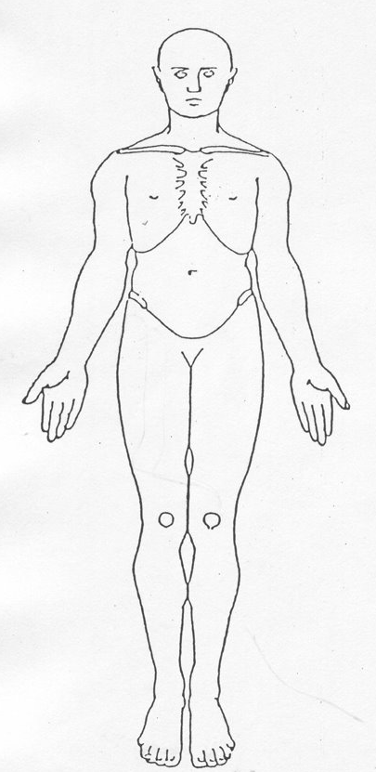 | 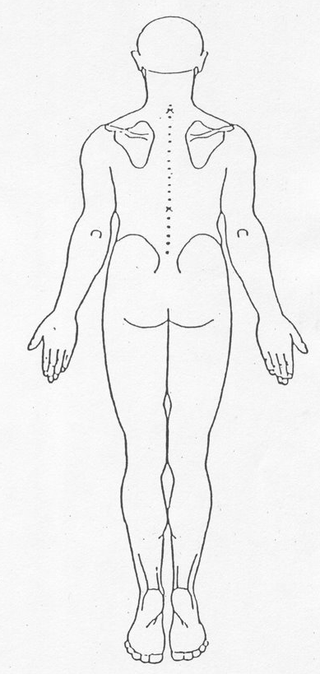
Body Map

Please use the section below to identify the position of any marks, bruising, wounds etc.

