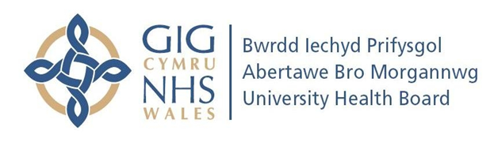

Bridgend Child Sexual Exploitation
&
Missing Children
Task Force

Terms of reference
Purpose
The Child Sexual Exploitation Task Force is a multi-agency working group focussing on concerns around child sexual exploitation and missing children within Bridgend County Borough Council. The primary focus of the Task Force is to protect vulnerable children and young people from sexual exploitation and prosecute perpetrators in addition to identifying and coordinating responses to for children who are reported as missing.

Objectives
- To share information across agencies, including the soft intelligence which will allow to plan appropriate response to CSE and missing children
- To map local information in relation to victims, locations and perpetrators
- To monitor the most vulnerable and high risk young people (those who are regularly missing and those with highest Seraf scores)
- To develop effect mapping and profiling of young people and perpetrators
- To use intelligence to disrupt perpetrator behaviour and pursue prosecutions
- Identify gaps in CSE training across the Borough of Bridgend
- To meet monthly to ensure CSE and missing children is a priority for all agencies
- To ensure data is provided, in a timely manner, for WBSCB performance monitoring.

Membership
- South Wales Police
- Bridgend County Borough Council – Childrens Safeguarding and Education
- Health
- Other agencies as necessary eg YOS, Probation
Frequency of Meetings
Monthly, Mondays 3-5pm at the Bridewell police station

