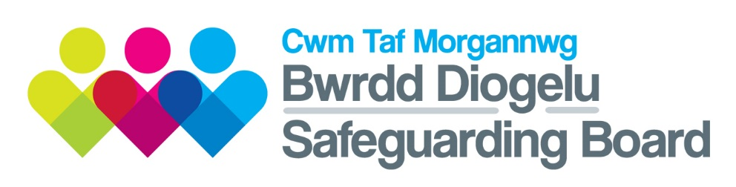

CWM TAF MASH OPERATIONAL COMMITTEE

TERMS OF REFERENCE

Version 4: July 2018
Approved:

- INTRODUCTION

This document has been produced in line with the guidance produced to support Part 7 of the Social Services and Wellbeing Act 2014 (Sections 134-138).

The Cwm Taf Multi-Agency Safeguarding Hub (MASH) is the single point of contact for all professionals to report safeguarding concerns.

AIM OF THE CWM TAF MASH OPERATIONAL COMMITTEE

The Cwm Taf MASH Operational Committee (MOP) is responsible for the overall management of the MASH to ensure it continues to achieve its goal to improve safeguarding and promote the welfare of children and adults at risk.

The MOP will receive reports from the MASH Quality Assurance Group (MAQA) on performance and learning from audits. It will also make decisions on any risks/issues escalated from the MAQA and refer up to the Regional Safeguarding Board as appropriate, any areas of concern that are beyond its remit.

OBJECTIVES

The specific objectives of the MASH Operational Committee are as follows:

- To oversee the delivery of the MASH Work Plan, which falls out of the Regional Safeguarding Board’s Annual Plan

- Review and improve processes both within the MASH and between the MASH and external agencies/services to ensure that multi-agency working is co-ordinated and is improving outcomes for children and adults at risk

- To ensure that information sharing within the MASH is effective, timely and is balanced between the right of the individual to privacy with the need to protect children, young people and adults at risk, with appropriate feedback mechanisms.

- To review decision making and ensure that thresholds are consistently applied within the MASH and that decisions are timely across all agencies.

- Understand and assess the impact on any developments within the MASH on individual agencies/services

- Consider and agree opportunities to continually align the work of the MARAC within the MASH structure

- To receive information from other MASH on safeguarding activity and areas of good practice

- To evaluate the ongoing benefits of the MASH and agree reporting mechanisms to the Cwm Taf Morgannwg Safeguarding Board

- To consider any barriers to effective working within the MASH and make decisions on how these can be addressed

- To ensure that MASH performance, audits and processes become embedded into existing Safeguarding Board functions, clearly evidencing outcomes.

- To work with the Board’s Engagement, Participation and Communications Sub Group to manage the effective communication and marketing of the MASH, both internal and external

- To consider issues escalated from the MASH Quality Assurance Group and agree actions to resolve

- To provide reports to the Cwm Taf Morgannwg Safeguarding Board via the MASH Operational Committee Chair.

- MEMBERSHIP

The membership of the MOP has been developed on a multi–agency basis and will consist of those managers that are able to make decisions on behalf of their respective agency.

MOP Members are required to:

- Prioritise attendance at MOP meetings and only in exceptional circumstances should a deputy attend; this deputy must also be in a position to make decision on behalf of their organisation.

- Be fully prepared for each meeting to ensure that they can actively contribute to discussions and provide robust challenge where appropriate.
- Communicate the work of the MOP within their agency in order to promote positive outcomes for children/adults at risk.

- Be able to influence decision making in relation to safeguarding children and adults at risk within their own organisation

- Promote the MASH priorities and outcomes as set out in the Work Plan.

- Be responsible for ensuring that all staff in their organisation are aware of the necessity of reporting safeguarding concerns

- Provide feedback to their agency on the work of the MOP and be held to account for the dissemination of information arising from the MOP

Record of Membership

The MASH Operational Committee will ensure that a list is maintained of those persons who are represented on the Committee. Attendance will be monitored. Members will be expected to participate in at least 75% of meetings. Fully briefed deputies will be substituted where they meet membership requirements.

TITLE | ORGANISATION
Superintendent | South Wales Police (Chair)
Service Director (Children) | RCTCBC (Vice Chair)
Detective Chief Inspector | South Wales Police
Head of Safeguarding | Cwm Taf University Health Board
Head of Children’s Services | MTCBC
Service Director (Adults) | RCTCBC
Deputy LDU Head | National Probation Service
Deputy LDU Head | Wales Community Rehabilitation Company
Access and Inclusion Manager | MTCBC
Head of Achievement (Primary) | RCTCBC
Head of Adults Services | MTCBC
Business Manager | Cwm Taf Morgannwg Safeguarding Board

- GOVERNANCE AND ACCOUNTABILITY

Chairing Arrangements
The Cwm Taf Morgannwg Safeguarding Board will appoint the Chair and Vice Chair of the MASH Operational Committee who will be Board members. This will be reviewed bi-annually. The MASH Operational Committee will meet at a minimum of 4 times a year.

Agendas and Reporting
The agenda for each meeting will be determined by the MASH Co-ordinator and the Chair.

The MASH Operational Committee will work to these agreed Terms of Reference with clear lines of reporting, communication and accountability to the Board and will report to the CTMSB by exception on a quarterly basis.

