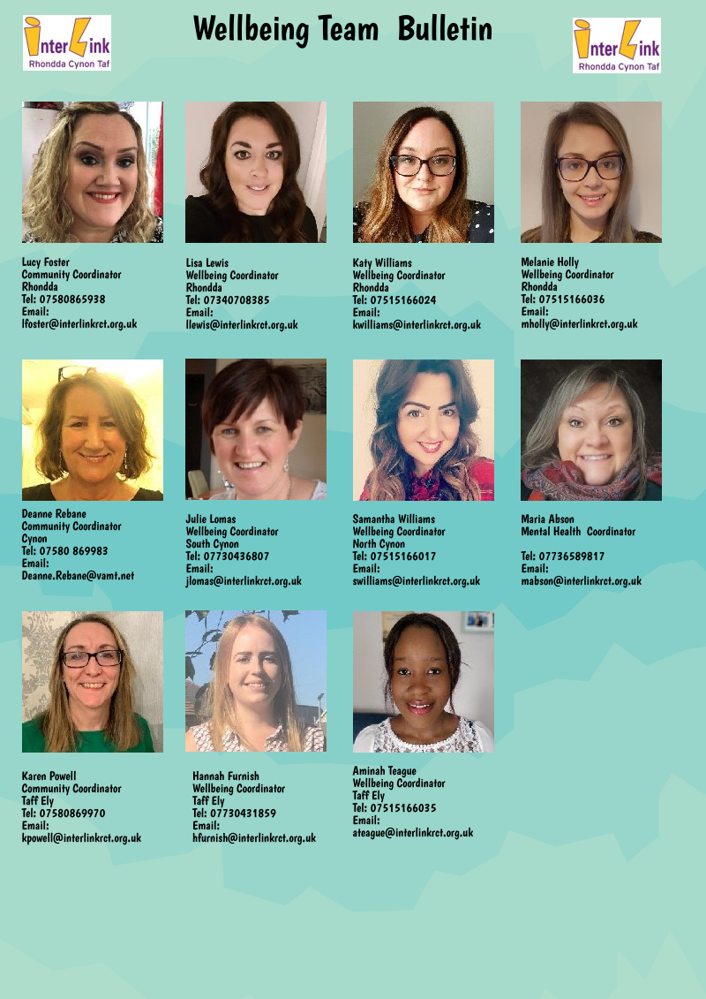

Rhondda Valleys
WR Bishop - Home deliveries or collection throughout Rhondda - £10/£20/£30 fruit and veg boxes/ £10 everyday essentials boxes. Contact 01443 670355.
Tonyrefail Coronavirus community network – Facebook group has been set up to coordinate support for those people who are most vulnerable in our community right now. https://www.facebook.com/groups/224513252034770/
Trehafod Covid19 community support group – Facebook support group – Contact Eleri Griffiths 07739731436. https://www.facebook.com/groups/659642164794006/about/
Ynyshir and Wattstown responds to Covid-19 - Supporting people in the local area providing a befriending service, picking up shopping/medication. Recruiting volunteers so that there is a network across the villages. Contact 07506 927581.
https://www.facebook.com/groups/203821430922018/
Pentre community support - Covid 19 - Community page supporting community members to stay connected during Covid-19 pandemic. https://www.facebook.com/Pentre-Community-Support-Covid-19-107835004185462/
Rhondda - Coronavirus Update and Support Group - Facebook page with the latest updates and support on the Coronavirus for Rhondda residents. https://www.facebook.com/groups/196502235014389/about/
Gilfach Goch Coronavirus help group – Facebook support group. https://www.facebook.com/groups/1382928705242919/

Cynon Valley
The Giving Group Aberdare and Mountain Ash - Facebook page states it’s a page for giving away free household items - However they are working with local churches and other local charities to also provide practical community support for people in the Cynon Valley in the current crisis. Message directly via the Facebook group https://www.facebook.com/TGGAberdareandMountainAsh
Contact Lorraine - 07594 910692 or rainycloux@gmail.com
Mountain Ash and & Abercynon Covid 19 Support Group– Contact Michelle Holland michelle1102@hotmail.co.uk
Cynon Valley Organic Adventures – Providing food parcels in the local community. They have some volunteer drivers. https://cynonvalleyorganicadventures.co.uk
Message Janis Werrett at janiswerrett@gmail.com
Chris Selwyn, Butchers Oxford Street, Mountain Ash CF45 3HB
Delivery - Need 24 hours notice
Meat for the Week pack - Available £10 for a variety pack. As well as fresh meat they sell eggs, cheese, pork pies, cooked ham and faggots.
PayPal and bank transfers, but if arranged a specific evening (preferably a Wednesday after 3.30) payment by card machine
email: rhi133@sky.com or call 01443 479292
St Fagans Church- Trecynon: Supporting people within the Community with Shopping, picking up prescriptions and medication. https://www.facebook.com/stfagansaberdare/ contact 01685 881435
Penywaun News: Sharing Local information in the area and local help and support. https://www.facebook.com/groups/1394763684182031/
Aberdare Covd 19 Support: Sharing local information and local support. https://www.facebook.com/groups/253228989026351 for more information.
Jenkins and Sons Fruit and Vegetables: Offering deliveries to local people of fresh fruit and vegetables. To place an order contact 07928074827
Working through the following areas: Penderyn all the way to Penrhiwceiber. https://www.facebook.com/JenkinsAndSonsAberdare/
Bryn Sion Church: Supporting local people within the community with food shopping, topping up gas and electric, collecting medication and prescriptions.
Contact 07486643961 Monday - Friday- 9am-5pm

Taff Ely
Taffs Well Village Hall Volunteer Support – support for anyone vulnerable of self-isolating in the Taffs Well area. Volunteers can support with a basic food pack delivered to your property, prescription delivery, urgent supplies or just a friendly phone call. Unfortunately, they not currently able to support with shopping on people’s behalf. Please call or text Zoe on 07721758323, Mike on 07796261093 or Dean on 07907436297.
Llanharan Community Resilience Volunteers – Support for those needing help with shopping or small errands due to self-isolating. Please contact Catherine Kennedy on 01443 231430 or 07745642136 or email actingclerk@Llanharancc.co.uk. Covering Llanharan and the surrounding area, including Pencoed and Pontyclun if needed. If you are willing and able to volunteer to carry out tasks for vulnerable people in this community, please also contact on the same details.
Hawthorn Covid-19 Community Support Group – anyone in need of essential practical help or a friendly phone call they will do their best to help with lcoal volunteers. If you need support please call 01443 540143 (from 9am-6pm, Monday to Friday, answerphone at other times).
Rhydyfelin and Treforest Covid-19 Community Support Group - anyone in need of essential practical help or a friendly phone call they will do their best to help with local volunteers. This support network is being looked after by Councillor Maureen Webber on 07885430690, Councillor Carl Thomas on 07841721832 and Councillor Steve Powderhill on 07795466252. If you need support please contact one of the above between 9am and 6pm, Monday - Friday.
Taff Ely Foodbank - Providing emergency support to those in crisis. Open at Bethel Baptist Church, Pontyclun. Monday - Friday, 9am-1pm. Offering deliveries of emergency food parcels to people self-isolating. Still accepting food donations (non-perishable) at local supermarkets and Bethel Baptist Church during opening hours. Contact Andrew Butcher on 07900 557379.
Pontypridd Foodbank - Providing emergency support to those in crisis. Open at St Luke's Church, Rhydyfelin, Monday & Friday 2-4pm and Wednesday 10am-12noon. Offering deliveries of emergency food parcels to people self-isolating. Please contact your housing officer, Citizens Advice or a member of your local wellbeing team (contacts on page 1) if you need a voucher. Still accepting food donations (non-perishable) at Sainsbury’s Ponytpridd and St Luke’s Church, Rhydyfelin during opening hours. Contact Mandy Haydon-Hall on 07562137392.

Across Rhondda Cynon Taf
Covid-19 RCT Fundraiser - Interlink are raising money for community and voluntary groups supporting communities with the Covid-19 pandemic. We want to promote and share this fundraiser to large private sector organisations – do you know someone who can help? Please share our Facebook page: Interlink Fundraising Page
Welcome Friends befriending service is offering telephone befriending to the over 50’s age group who find themselves needing contact. Volunteers are needed to keep this service active, as well as support older people with essential tasks. Please contact Diane Matheson on 07788 310445 to find out more, or alternatively register to volunteer online: https://forms.gle/628Zdnmiqv62jzZW6
Hafal Cwm Taf - currently providing telephone support and advice for existing clients and for those on their waiting list. They are accepting new referrals for those in need of mental health support. For people experiencing financial difficulties, a phone appointment can be organised with the excellent Hafal Mental Health and Money Advice Service. They also have free online support forum called Clic. Hafal’s Facebook page has daily vlogs relating to wellbeing and exercise. Anyone needing support can ring 01792 816600 and ask to be redirected to a member of the Cwm Taf team. https://www.hafal.org/coronavirus/.
Eye to Eye - Young People Counselling Service, offering free and confidential online counselling for young people aged 11- 25 years plus, year 6 pupils across RCT. Contact on: 07541 783767 or info@eyetoeye.wales or visit www.eyetoeye.wales
Click Here
New Horizons Corona Virus Mental Health & Wellbeing Signposting Helpline – Call 01685 881113 or email info@newhorizons-mentalhealth.co.uk. Monday-Friday, 9am-4pm. Leave your name and details and you will receive a call back from a withheld number. Depending on demand you may not hear back the same day.
Spectacle Theatre - Online chair dancing, creative writing, poetry and short story service. Contact: 01443 681024 www.spectacletheatre.co.uk
https://www.facebook.com/pages/Theatr-Spectacle-Theatre/393368894047288
Coop Vulnerable Care Line - Central call centre, that will liaise with the local store, check the items are in stock, phone the resident back to make a payment over the phone and then it can be collected. Contact 03300 417784

Reconnect 50+ Project - Offers telephone support to those who are aged 50+ alone and isolated. For more information email hm@smt.org.uk.
- Information can be offered regarding local area practical support availability to what best meets the individual's needs.
- Activity packs can be sent out on request containing for example, quizzes, word search and cooking recipes.
Tenovus Cancer Care - Free nurse-led Support Line will remain open to answer questions from cancer patients and indeed anyone affected by cancer. Our experienced nurses can offer advice on diagnosis, treatment, side-effects, and anything else that’s on people’s minds. Just call 0808 808 1010.
RCT Domestic Abuse Support Services - RCT council’s Oasis Centre provides support to male and female victims of domestic abuse aged 16 or over.
01443 494190 - Answer phone Advice Service (24 hour)
07795 391674 / 07867373200 – In urgent need of support
(Mon – Fri 9am – 5pm) Email: PontypriddSafetyUnit@rctcbc.gov.uk
24 hour / 365 days
Live Fear Free Helpline - 0808 80 10 800 Email: info@livefearfreehelpline.wales
RCT & MT Mental Health Facebook Page - This page promotes Mental Health services, events and activities locally in Rhondda Cynon Taf and Merthyr Tydfil. Please note this page is not a support group or crisis helpline service, it advertises these types of services. https://www.facebook.com/mentalhealthcwmtaf/?ref=bookmarks
Calm - Website and app for Sleep, Meditation and Relaxation https://www.calm.com/
Headspace - App for Sleep, Meditation and Relaxation
https://www.headspace.com/headspace-meditation-app
Valleys Steps – Online resources for Mindfulness and Stress Control
http://www.valleyssteps.org/
Elefriends - is a supportive online community chat room for mental health where you can chat about lived experiences and be yourself. We all know what it is like to struggle sometimes, this is a safe place to listen, share and be heard.
https://www.elefriends.org.uk/
Nice - Information and guidelines on treatments for conditions, including anxiety.
No Panic - Information, support and advice for those with panic disorder.

DASPA - Support or advice regarding drug and alcohol misuse, Providing a telephone support service available Monday – Friday. Contact 0300 333 0000.
Hapi – Daily Facebook live wellbeing videos including cooking skills, family keep fit, Pilates and singalongs
https://www/facebook.com/hapiRCT

