

**GUIDANCE ON WORKING WITH PEOPLE WHO ARE UNCOOPERATIVE**

*Adapted from 7 minute briefing created by Hywel Dda University Health Board*

**3) Reasons**

**2) Recognition**

1. **Purpose and Definition**

There are a variety of reasons why families may be uncooperative including:

* Not wanting their privacy invaded.
* They have something to hide.
* Refusing to believe there’s a problem.
* Resenting outside interference.
* Cultural and language differences.
* Poor experience or fear of professionals.
* A fear of being judged.
* Mental health issues

The guidance helps practitioners to respond when working with reluctant and uncooperative people and families.

There can be a wide range of uncooperative behaviour. All staff will deal with people whose engagement with services is apparent rather than genuine, or who are reluctant, resistant or sometimes angry.

There are 5 types of non-cooperation that staff may recognise/experience when working with families:

* Ambivalence
* Avoidance
* Disguised Compliance
* Confrontation
* Violence

**Full details can be found on the CTMSB website** [**here**](https://bit.ly/2S35sVA)

1. **Response**

**4) Impact on Assessment**

Professionals can improve the chances of good outcomes by:

* Maintaining boundaries
* Continuously assessing the motivations/capacities of the parent/carer
* Helping the parent/carers to work through underlying feelings
* Being alert to underlying complete resistance
* Being willing to take action to protect
* Establishing clear, measurable objectives that enable progress to be monitored.

Accurate information & a clear understanding of what is happening to a child/adult at risk is vital. The most effective way to achieve this is by engaging parents, carers, the child or adult in the assessment.

Engaging with someone who is uncooperative is difficult. It is important to explicitly work out & record what areas of assessment are difficult to achieve and why.

The presence of violence or intimidation should be included in an assessment of risk to the child or adult living in such an environment.

[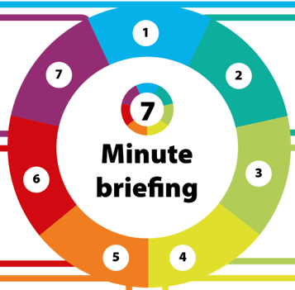](https://www.google.co.uk/url?sa=i&rct=j&q=&esrc=s&source=images&cd=&ved=2ahUKEwjYyujwlqvmAhVkDWMBHcuRCYQQjRx6BAgBEAQ&url=https%3A%2F%2Fwww.safeguardingwarwickshire.co.uk%2F&psig=AOvVaw3OmBWPsppeiWIV9axgFawJ&ust=1576070656373011)

**6) Supervision and Support**

All agencies should support their staff by:

* Ensuring they are trained for the level of work they are undertaking
* Publishing a clear statement about unacceptable behaviour by those accessing their services
* Providing training to enable staff to respond as safely as possible to risky or hostile behaviour
* Supporting staff to work to their own or their agency’s code of conduct when responding to risky or hostile behaviour in their client group

Any professional or agency faced with incidents of threats, hostility or violence should routinely consider the potential implications for any other professional or agency involved with the family, in addition to the implications for themselves and should alert them to the nature of the risks as they occur.

Regular inter-agency communication, clear mutual expectations and attitudes of mutual respect and trust are the core of inter-agency working. When working with hostile or violent Parent/Carers, the need for very good inter-agency collaboration and trust is paramount.

**5) Impact on Multi-Agency Working**

**What next?**