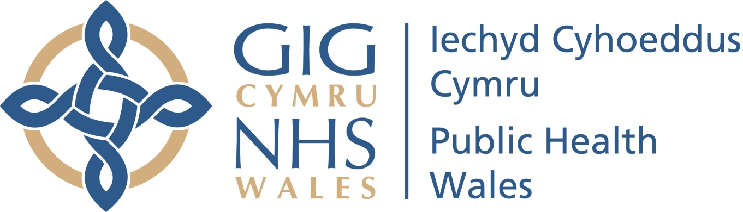Child Death Review Programme Wales

Child death notification form

- REPORTING DETAILS: (Your Details)

Date of Completion |  | Welsh Paediatric Surveillance number  (if applicable)
Full name and role

Organisation
E-mail address

- CHILD’S DETAILS

Full name of child
Date of birth |  | NHS No.
Home address (normal residence
of child)
Postcode |  | Sex | Male | Female
Was the child on the Child Protection Register? | At the time of death Previously Not at all
Was the child a “Looked after Child” | At the time of death Previously Not at all  If yes, what local authority?
Was the child in receipt of any of additional services?’ | Team around the Family (TAF)  At the time of death Previously Not at all  Integrated Family Support Service (IFSS)  At the time of death Previously Not at all  Flying Start  At the time of death Previously Not at all  Families First  At the time of death Previously Not at all

- DETAILS OF THE DEATH

Date of death |  |  |  |  |  |  | Time of death
Where did the event which led to the death occur? |  |  |  |  |  |  |  | Home Hospital Other
Address of event (if hospital or other)?
Where was death confirmed? |  |  |  | Home Hospital Other
Has this death been referred for any other type of review? |  |  |  | Child practice review Hospital morbidity/mortality  Domestic homicide review Criminal investigation
Has the death been reported to Welsh Government as a serious incident? (as defined in section 9.2 of Putting Things Right) |  |  |  |  |  |  |  |  |  | Yes No
Medical certificate for the cause of death issued? |  |  |  |  | Yes No
If yes, please state cause of death |  |  |  |  | If no, what is your understanding of the cause of death?
Death expected? | Yes No |  |  |  | Was an advance (end of life) care plan in place? |  |  |  | Yes No Not known
Has a PRUDiC been implemented? | Yes x No
An unexpected death is defined as the death of a child which is a not anticipated as a significant possibility 24 hours before the death or where there was a similarly unexpected collapse leading to or precipitating the events which led to the death
Was the death referred to HM Coroner? Yes No
If yes state date reported and name of HM Coroner?
Post mortem date and venue |  |  |  |  |  |  | Has an inquest been held?
D. ADVERSE CHILDHOOD EXPERIENCES

Please select all that you are aware of in relation to the social background of the child
verbal abuse |  | physical abuse |  |  |  | sexual abuse |  |  |  |  | parental separation
household domestic violence |  | household mental illness |  |  |  | household alcohol abuse |  |  |  |  | household drug use
household member incarcerated |  | household physical health issues |  |  |  | household disability (including learning disability) |  |  |  |  | neglect
Did the child perform any caring duties? |  | Yes No  If yes, who for? Parent sibling other

E. NARRATIVE OF CIRCUMSTANCES AND HISTORY

Please record:
Circumstances leading to death:

Relevant past history:

Relevant social and family circumstances:

Any other relevant information:

Please complete the relevant section on the next page for:
- Sudden unexpected deaths in infancy
- Deaths from drowning
- Deaths from apparent suicide
- Deaths in motor vehicles
- Deaths from fire

- MODIFIABLE FACTORS – please record if any of the following factors were present

Sudden Unexpected Death in Infancy (under 2 years old)
Co-sleeping at time of death | Yes No Not known
Sofa sleeping at time of death | Yes No Not known
Parental smoking | Yes No Not known
Illness in child in week prior to death | Yes No Not known
Parental history of drug use | Yes No Not known
Parental alcohol use at time of death or past history of concern | Yes No Not known
Drowning
Ability to swim | Yes No Not known
Possible alcohol consumption | Yes No Not known
Lack of active supervision | Yes No Not known
Deaths in Motor Vehicles
Seatbelt use (or appropriate car seat) | Yes No Not known
Driving at night | Yes No Not known
Driving over legal blood alcohol limit | Yes No Not known
Apparent Suicide
Known to CAMHS | Yes No Not known
Known to youth offending services | Yes No Not known
History of alcohol abuse | Yes No Not known
History of drug misuse | Yes No Not known
Bullying | Yes No Not known
Fire
Working smoke alarm in house | Yes No Not known

NEXT STEPS

Please send the completed form to the Child Death Review Programme:

Email: An e-mail attachment to ChildDeath.Review@wales.nhs.uk

Post: Child Death Review Programme Team, Public Health Wales, 1st Floor Matrix House, Northern Boulevard, Swansea Enterprise Park, Swansea, SA6 8DP.

Tel: 01792 940938 or 01792 940939

